How to join the Teacher Candidate Support Network 2025-2026 using the promo code:
Great! You have filled out the Wufoo form and been emailed a promo code for FREE Student Teacher Basic membership with CEC. Now what? There are still necessary steps before you can start taking advantage of your CEC membership.
- Go to exceptionalchildren.org on your browser.
- Log into your CEC account (if you already have one) and hover over your name. Select “Renew your membership”. If you do not already have an account, select “Join” in the upper right-hand corner of your webpage.
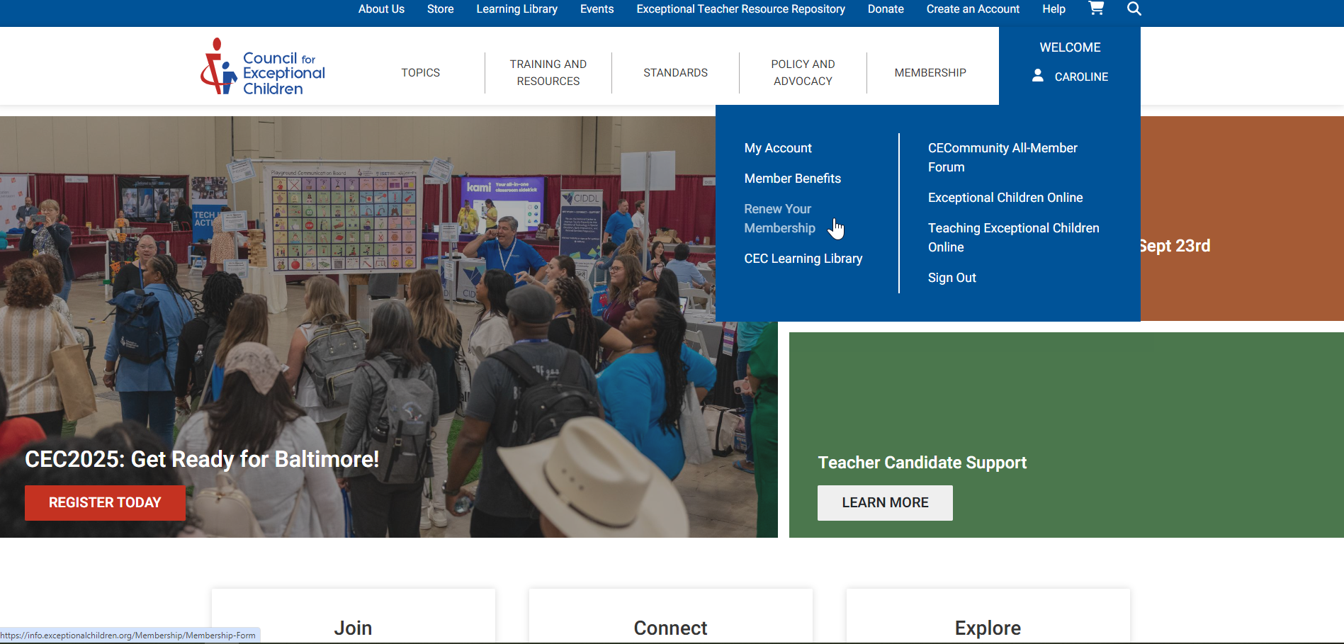

- You will then see a screen that looks like this (if you are an existing member). Yours will have your information and “pre-service student” will be selected, or you will need to select it. Continue by clicking the red “next” at the bottom right corner of the screen to move through the application.
- If you selected “join” in the last step, you will be brought to screen where you will need to select that you are a “pre-service student”. Select that you want to join as a “student teacher” and follow prompts to register on your screen.
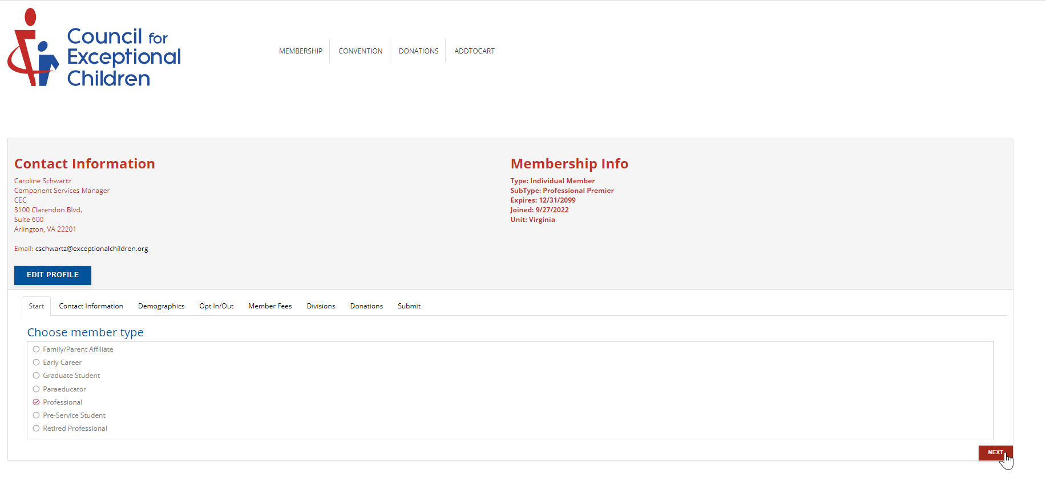

- When you reach a screen that looks like this, it’s time to use the promo code that was sent to you in an email by CEC. Again, make sure that the membership in your shopping cart is a “Student Teacher Basic” membership. The picture below serves as an example of what the screen will look like but is not an accurate representation of the member type. Make sure it says, “student teacher”. Select “apply promotion” and then “proceed to check out”. Continue to follow the prompts to check out free of charge.
